PEEP

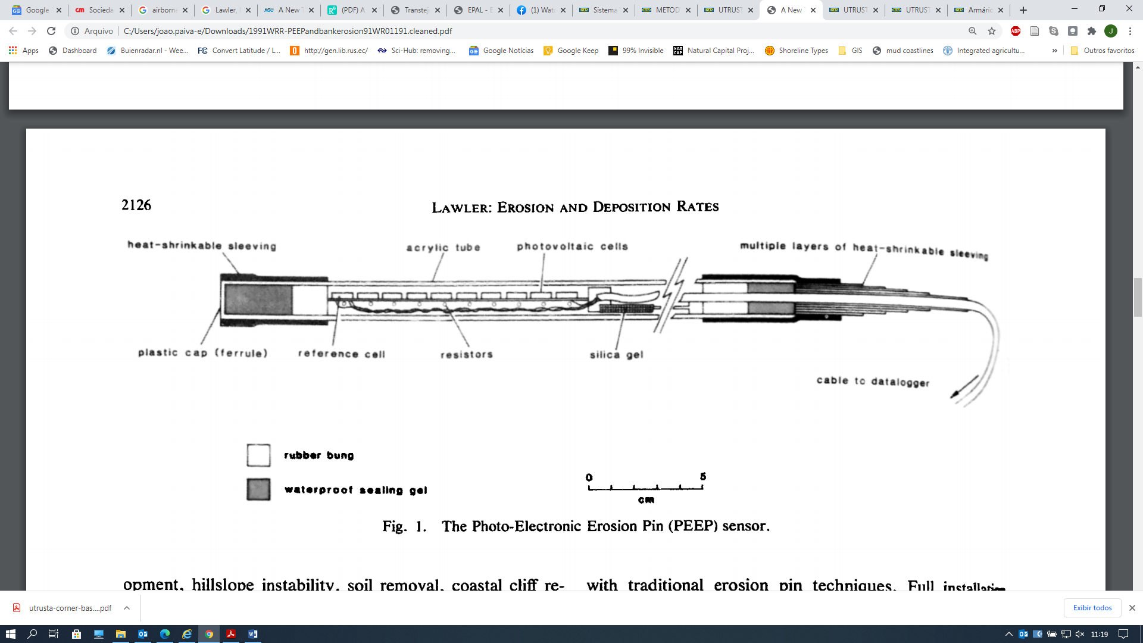

|  |  |
| --- | --- |
| **Goal** | Morphological measurements |
| **Typical area** | River banks, gullies, canals, tidal mudbanks |
| **Typical time resolution** | Days–months |
| **Investment costs** | < 1750 € |
| **Operation Costs** |  |
| **Labor** | low |
| **Spatial Coverage** | spot |
| **Time Frequency** | continuous |
| **Detail level** | High (2 mm vertical resolution) |

**Method**

.

**Materials**

Photo-Electronic Erosion Pin (PEEP) system

**Additional information**