Wild Camera

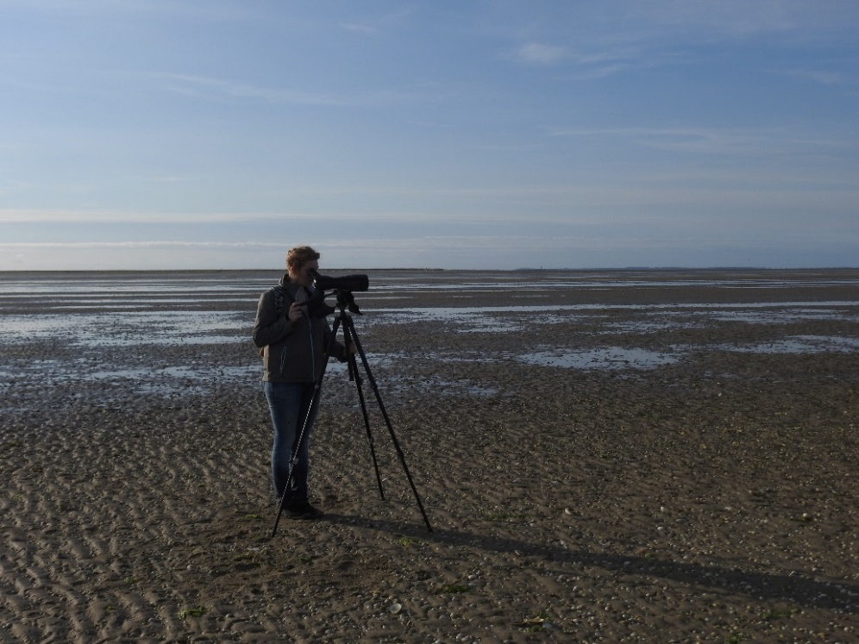

|  |  |
| --- | --- |
| **Goal** | Bird counting and identification |
| **Typical area** | Tidal Flats, salt marshes, beaches, dunes, mangroves |
| **Typical time resolution** | Weeks–decades |
| **Investment costs** | 3250 € per camera |
| **Operation Costs** | 70€ per month (AA batteries plus operator) and more than one camera can be done with this cost. |
| **Labor** | low |
| **Spatial Coverage** | Spot (one camera per 900 m2) |
| **Time Frequency** | Interval (one foto every 3 minute: 14,400 measurements per month) |
| **Detail level** | medium (medium and large birds are easily identified small birds can be counted) |

**Method**

The operator installs the camera on a pole (3m high). The camera is setup for taking pictures every 3mins. In this way the batteries last a month. Higher time frequency up to movie can be selected but battery replacement and operations cost are expected to rise. The pictures are later analyzed. Birds can be counted and identified by a bird specialist. With this method you can also identify what activity the bird is doing, e.g. resting, feeding, etc.

**Materials**

* Wild camera on a pole;
* Batteries

**Additional information**

The image analysis only need to be done by a specialist if identification is needed.