SED Sensor

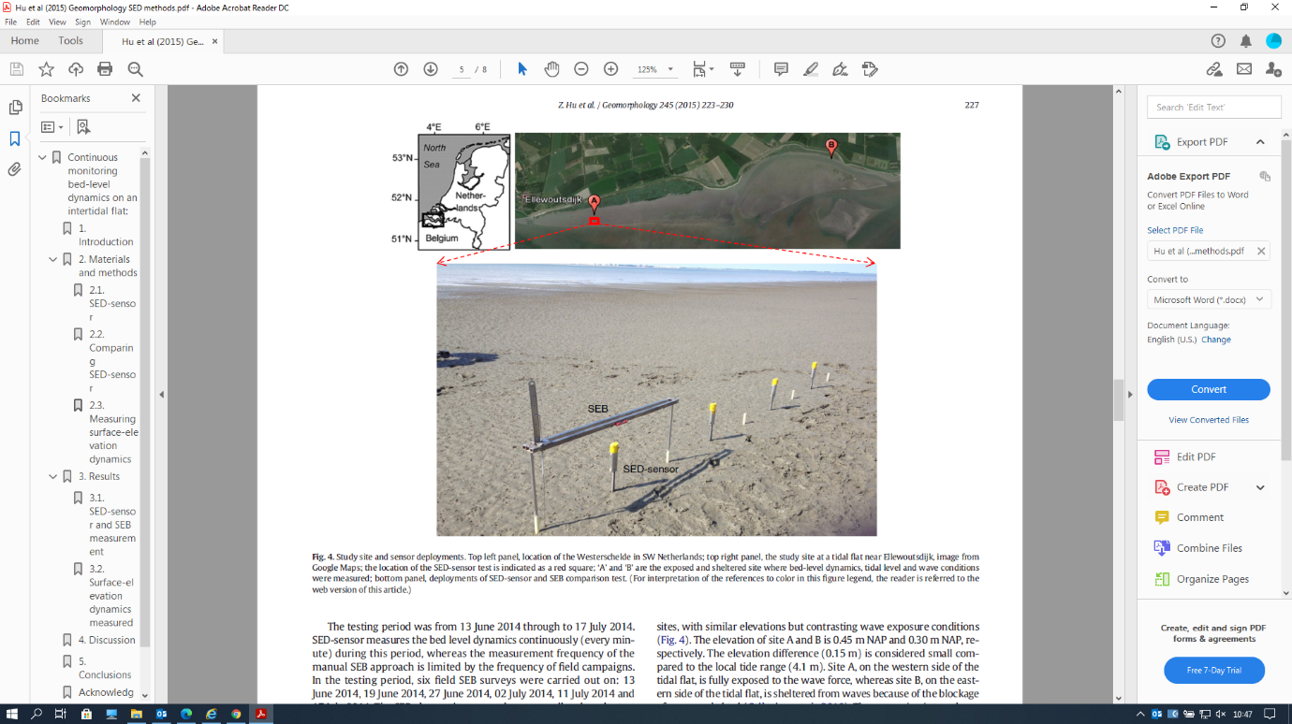

|  |  |
| --- | --- |
| **Goal** | Morphological measurements |
| **Typical area** | Salt marshes, mangroves, tidal flats, dunes, beaches |
| **Typical time resolution** | Days–months |
| **Investment costs** | < 1000 € |
| **Operation Costs** |  |
| **Labor** | low |
| **Spatial Coverage** | spot |
| **Time Frequency** | continuous |
| **Detail level** | High (2 mm vertical resolution) |

**Method**

When in use, a SED-sensor is inserted vertically into the seabed, leaving ca. half of the measuring section above the seabed. During measurement, a current runs through each light sensitive cell, which is proportional to the amount of light on each cell. This current is measured over a resistor to give a voltage output. In this way, above-ground and below-ground cells will give higher and lower output accordingly.

**Materials**

* Sed Sensor

**Additional information**