DGPS-RTK

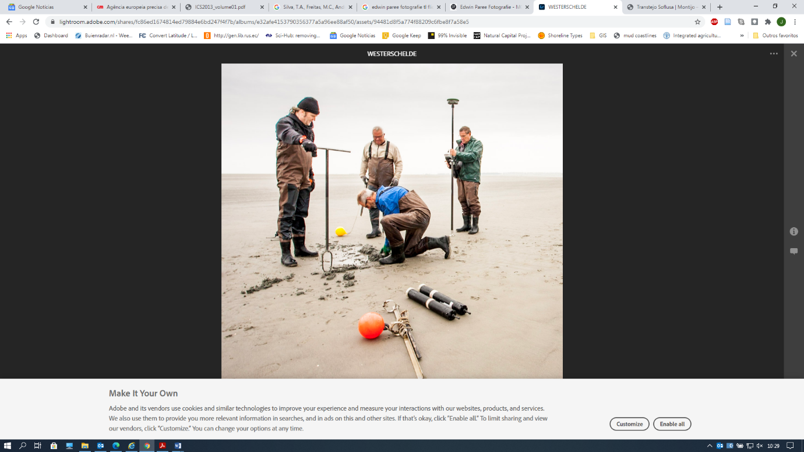

|  |  |
| --- | --- |
| **Goal** | Morphological measurements |
| **Typical area** | Salt marshes, mangroves, tidal flats, dunes, beaches |
| **Typical time resolution** | Weeks–decades |
| **Investment costs** | < 25,000 |
| **Operation Costs** |  |
| **Labor** | High |
| **Spatial Coverage** | Medium (~ 1 km) |
| **Time Frequency** | Interval |
| **Detail level** | High 5–25 mm vertical resolution) |

**Method**

The operator walks with the DGPS-RTK in transects line or areas marking the terrain at certain distances. It is important to measure all the important features in terrain (e.g. deeper points or channels). In this way the cross sections or interpolated surfaces are more realistic.

**Materials**

DGPS-RTK

**Additional information**