Electro-resistivity sensor

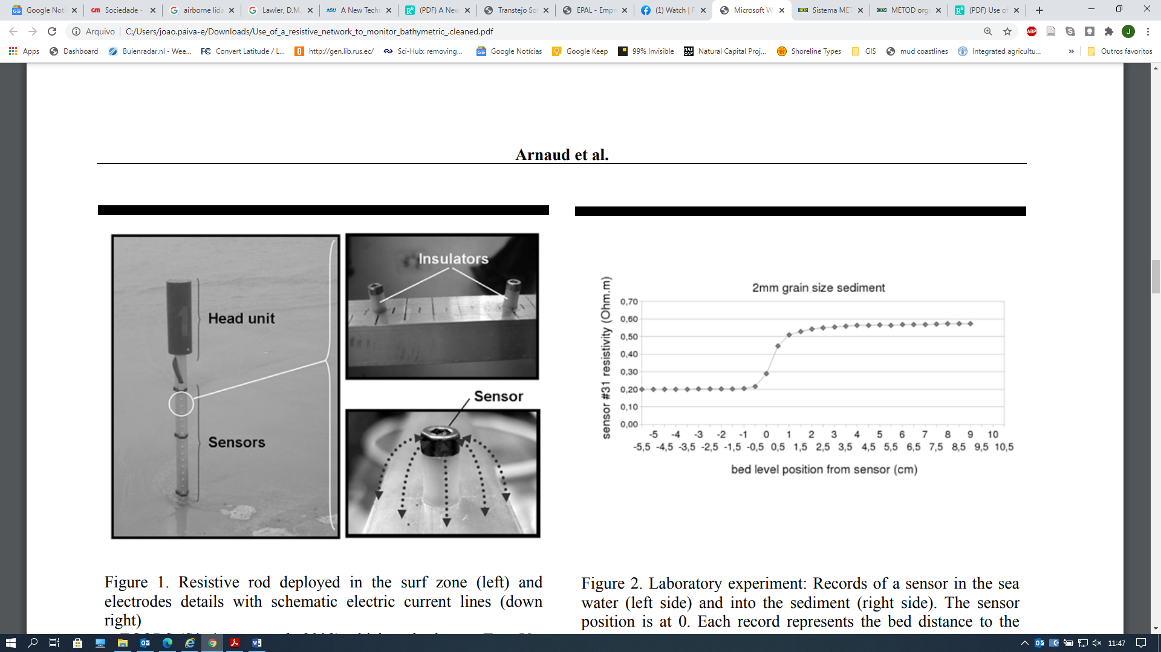

Arnaud, G., Mory,M., Abadie, S., Cassen,M., 2009. Use of a resistive rods network to monitor bathymetric evolution in the surf/swash zone. J. Coast. Res. 1781–1785.

|  |  |
| --- | --- |
| **Goal** | Morphological measurements |
| **Typical area** | Beaches |
| **Typical time resolution** | Intra-tide–months |
| **Investment costs** | < 6000 € |
| **Operation Costs** |  |
| **Labor** | medium |
| **Spatial Coverage** | spot |
| **Time Frequency** | continuous |
| **Detail level** | low (10-30 mm vertical resolution) |

**Method**

.

**Materials**

* Electro-resistivity sensor

**Additional information**