**Guided Conversation Participant Handbook Template**



**Administrative**

1. **Information about your organisation / project.**
2. **Consent Checklist – if data is being recorded, a ‘Yes / No’ checklist can help participants agree on how their data will be used and confirm this via their signature.**

|  |
| --- |
| **[Visual prompt / space for notes and drawing 1]** |

**[Radar 1 Title]**

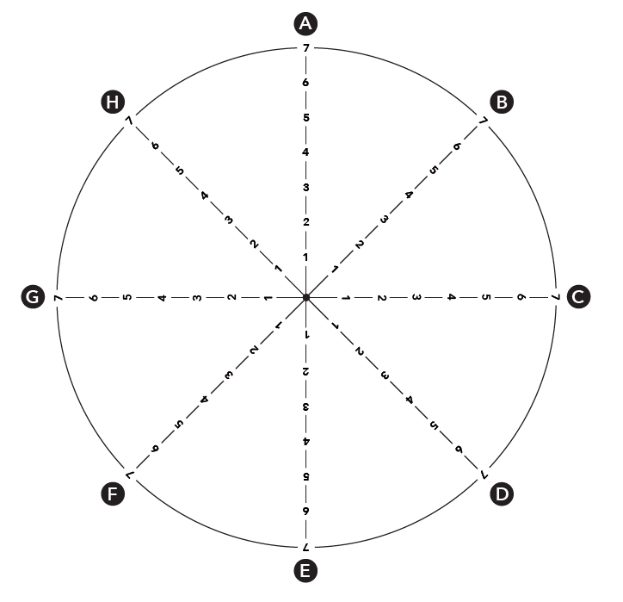

**[Topic A]**

**[Topic B]**

**[Topic C]**

**[Topic D]**

**[Topic E]**

**[Topic F]**

**[Topic G]**

**[Topic H]**

|  |
| --- |
| **[Visual prompt / space for notes and drawing 2]** |

**[Radar 2 Title]**



**[Topic A]**

**[Topic B]**

**[Topic C]**

**[Topic D]**

**[Topic E]**

**[Topic F]**

**[Topic G]**

**[Topic H]**

|  |
| --- |
| **[Visual prompt / space for notes and drawing 1]** |

**[Radar 3 Title]**



**[Topic A]**

**[Topic B]**

**[Topic C]**

**[Topic D]**

**[Topic E]**

**[Topic F]**

**[Topic G]**

**[Topic H]**

**Action Plan Notes:**

**Signpost:**

**Support:**

**Referral:**

**[DELETE THE CONTENT THAT FOLLOWS THIS PAGE IF FOLLOW-ON CONVERSATIONS ARE NOT RELEVANT]**

**[Radar 1 Title] Update**



**[Topic A]**

**[Topic B]**

**[Topic C]**

**[Topic D]**

**[Topic E]**

**[Topic F]**

**[Topic G]**

**[Topic H]**

**[Radar 2 Title] Update**



**[Topic A]**

**[Topic B]**

**[Topic C]**

**[Topic D]**

**[Topic E]**

**[Topic F]**

**[Topic G]**

**[Topic H]**

**[Radar 3 Title] Update**



**[Topic A]**

**[Topic B]**

**[Topic C]**

**[Topic D]**

**[Topic E]**

**[Topic F]**

**[Topic G]**

**[Topic H]**

**Action Plan Update**

**Signpost:**

**Support:**

**Referral:**